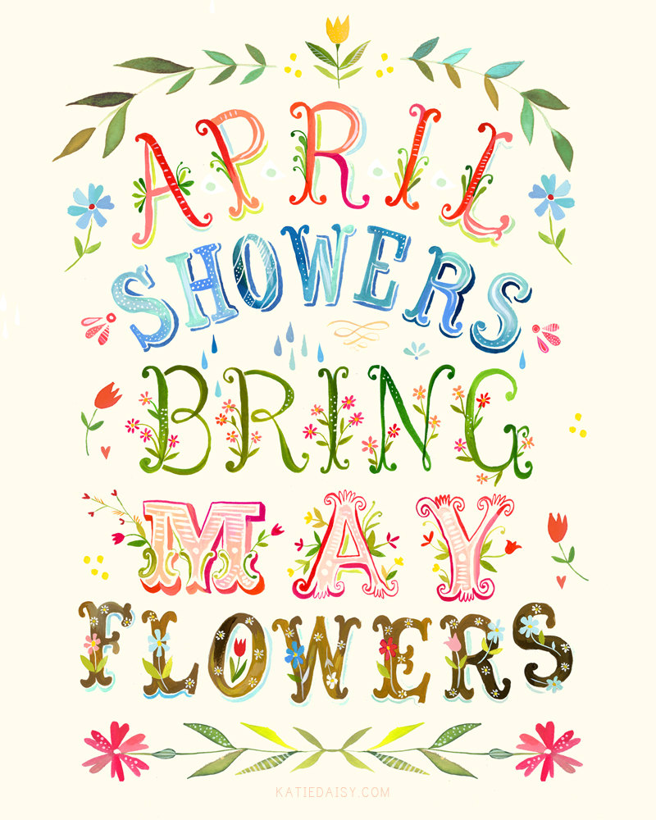

Related Arts Schedule
Jett: P.E.
McHolland: Library
Fluharty: Arts and Humanities

Upcoming Events
19th – Last PTA Skating Party 6:00 pm
19th --Talent Show Try-outs – During Special Area Class
22nd – Earth Day
28th – PTA & SBDM Elections and Talent Show 6:00 pm
29th– Talent Show for School 2:15 pm

Reminders
- Please bring a jacket! We will go out to recess each day as long as it is above 40 degrees.
- Dress Code: Shorts and skirts must be longer than your child’s fingertips when their arms are to their sides.
- Shoes must have a back.

This Week
April 12th – April 16th

Dear Parents/Guardians,
Welcome back! We hope you had a wonderful spring break. It’s hard to believe we only have 33 days of school left. This year has absolutely flown by. We still have lots to learn! This week we will wrap up our unit on cause and effect. In Math we will continue to work on data and graphs. We are working on constructed responses in writing and will continue to work on landforms in Social Studies. We will have a test on Unit 9 on Friday.
We have cumulative learning checks coming up in Math and Reading next week and Map Testing will begin in early May. We will also be doing our end of year DRAs in early May.
Congratulations to Austin Tower for winning a brand new bicycle for perfect attendance. In order to get KONA Ice in May you must be at school each day without a tardy or early check out. Thank you for all that you do!
Sincerely,
Mrs. Jett, Mrs. McHolland, Mrs. Fluharty
April Students of the Month
Jack Morgan
Jayla Goodwin
Avery Hooper

What we are studying
this week in 1st Grade
Math:
- Data and Graphs
- Reading Unit 9: Cause and Effect
- Text Features
- Writing: Adding adjectives
- Phonics: /oo/
- Social Studies: Landforms

