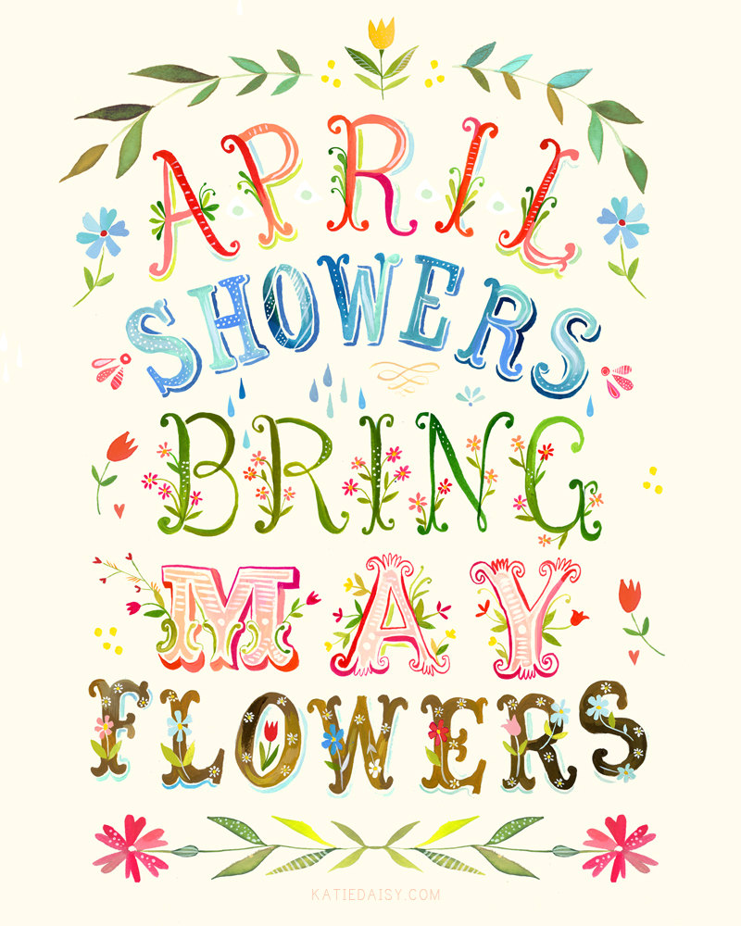

Related Arts Schedule
Jett: Library
McHolland: Science Lab
Fluharty: P.E.

Upcoming Events
19th – Last PTA Skating Party 6:00 pm
19th --Talent Show Try-outs – During Special Area Class
22nd – Earth Day
28th – PTA & SBDM Elections and Talent Show 6:00 pm
29th– Talent Show for School 2:15 pm

Reminders
- Please bring a jacket! We will go out to recess each day as long as it is above 40 degrees.
- Dress Code: Shorts and skirts must be longer than your child’s fingertips when their arms are to their sides.
- Shoes must have a back.

This Week
April 18th-22nd
2th – April 16th

Dear Parents/Guardians,
Greetings! We hope you had a lovely weekend. This weather is wonderful. This week we will begin Unit 10 in Reading and we’ll be revisiting inferences and drawing conclusions. In Math we will begin our unit on geometry. We are very excited about Science this week as we will be studying bridge-building Ants to talk about how humans can mimic animal behavior to solve problems. Students will have an opportunity to build bridges themselves and test their bridge’s strength. We have cumulative learning checks coming up in Math and Reading this week and next and Map Testing will begin in early May. We will also be doing our end of year DRAs in early May.
Congratulations to Austin Tower for winning a brand new bicycle for perfect attendance. In order to get KONA Ice in May you must be at school each day without a tardy or early check out starting May 9th. Thank you for all that you do!
Sincerely,
Mrs. Jett, Mrs. McHolland, Mrs. Fluharty
April Students of the Month
Jack Morgan
Jayla Goodwin
Avery Hooper

What we are studying
this week in 1st Grade
Math:
- Geometry
- Reading Unit 10: Making Inferences and Drawing Conclusions
- Text Features
- Writing: Constructed Responses
- Phonics: /ou/
- Science: Animal Behaviors

