This Week
February 29th – March 3rd
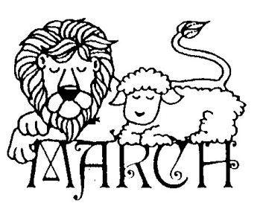
Dear Parents/Guardians,
It’s hard to believe that Spring is on its way. We’ve been lucky to enjoy a few nice warm afternoons on the playground which have been well deserved as content gets more and more challenging. The end of the year is approaching and our first graders have learned so much but we still have two months to go. Thank you for helping your student return homework completed and on time. We try to send home just enough to give them a few minutes of extra practice each night as well as help to prepare them for the independence they’ll need in second grade.
March is shaping up to be a very busy month. Make sure you look at the sidebar for upcoming events.

Related Arts Schedule
Jett: Arts and Humanities
McHolland: PE
Fluharty: Science Lab

Upcoming Events
March 10th – Individual and Group Pictures
March 15th- PTA Skating Party
March 18th – Snow Make Up Day
March 21st – Teacher Planning Day/No Students
March 22nd-25th- Book Fair
March 28th- April 1st- Parent Teacher Conferences

Reminders
- Please bring a jacket! We will go out to recess each day as long as it is above 40 degrees.

Thank you for all that you do!
Sincerely,
Mrs. Jett, Mrs. McHolland, Mrs. Fluharty
February
Students of the Month
Rickie McAllister
Lily Cox
Grant Turbeville

What we are studying
this week in 1st Grade
Math:
- Measurement
- Reading Unit 8: Compare and Contrast
- Text Features
- Opinion Writing
- Phonics: R Blend digraphs
- Social Studies: Maps and Globes

