Related Arts Schedule
Jett: Library
McHolland: Science Lab
Fluharty: PE

Upcoming Events
March 15th- PTA Skating Party
March 18th – Snow Make Up Day
March 21st – Teacher Planning Day/No Students
March 22nd-25th- Book Fair
March 28th- April 1st- Parent Teacher Conferences
April 4th – 8th: Spring Break!

Reminders
- Please bring a jacket! We will go out to recess each day as long as it is above 40 degrees.

This Week
March 14th - 18th
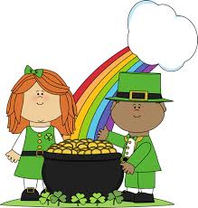
Dear Parents/Guardians,
Wow! We love this spring weather- (maybe not the rain during our recess.) The warmer temps mean it’s almost Spring and all the fun that entails. This week we will start Unit 9 in our Benchmark Reading Series and we will be studying Cause and Effect. We have just finished our unit on measurement in Math and will now move on to Time. We will be working on our Young Authors projects during writing time. Please make sure you are checking your student’s planner and the side bar for important events and announcements.
Our groovy literacy night will be on the 24th. We’ll be sending more details home in the coming days but as a heads up- start getting your tie-dye shirts and bell bottoms out! We’ll also be sending home conference notes soon. You do not have to meet with us this round unless you have a particular concern or question.

Thank you for all that you do!
Sincerely,
Mrs. Jett, Mrs. McHolland, Mrs. Fluharty
March
Students of the Month
Gavin Morgan
Jacob Powell

What we are studying
this week in 1st Grade
Math:
- Time
- Reading Unit 8: Compare and Contrast
- Text Features
- Writing: Young Authors Projects
- Phonics: Words with /oo/
- Social Studies: Landform

