Related Arts Schedule
Jett: Science
McHolland: Arts and Humanities
Fluharty: Library

Upcoming Events
March 21st – Teacher Planning Day/No Students
March 22nd-25th- Book Fair
March 23rd- Report Cards go home
March 28th- April 1st- Parent Teacher Conferences
April 4th – 8th: Spring Break!

Reminders
- Please bring a jacket! We will go out to recess each day as long as it is above 40 degrees.

This Week
March 21st-25th
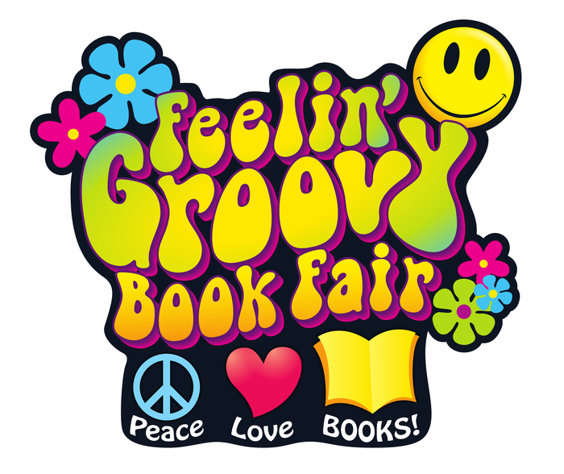
Dear Parents/Guardians,
We have a groovy week ahead. Break out the bell bottoms, tie-dye and peasant blouses on Thursday. Students are invited to wear their most fab 70s wear to school. (Wait until you see the teachers!) Are you ready for a far-out time at our Literacy Night? Don’t be a jive turkey. Boogie down to Freedom Elementary on March 24th at 6:00 for pizza (no moolah needed- that pizza is free and so are all the rad literacy activities we’ll have for you) The Book Fair will be open and there will be tons of neat-o books for sale. So be a real cool cat, and stay until 7:30. Peace!
Conference notes go out this week. You do not have to meet with us this round unless you have a particular concern or question but feel free to schedule a conference if you wish.
Thank you for all that you do!
Sincerely,
Mrs. Jett, Mrs. McHolland, Mrs. Fluharty
March
Students of the Month
Gavin Morgan
Jacob Powell

What we are studying
this week in 1st Grade
Math:
- Time
- Reading Unit 9: Cause and Effect
- Text Features
- Writing: Young Authors Projects
- Phonics: Inflected endings
- Social Studies: Landform

