Related Arts Schedule
Jett: P.E.
McHolland: Arts and Humanities
Fluharty: Library
Upcoming Events
May 23rd- Field Day
May 24th Wulfe Brothers
May 25th Kona Ice Attendance Reward

Reminders
- Dress Code: Shorts and skirts must be longer than your child’s fingertips when their arms are to their sides.
- Shoes must have a back.
- ALL Word Lists and Book Logs are due by May 27th. Students should be on the 25th word list and should have read 160 books.

This Week
May 23rd- May 27th

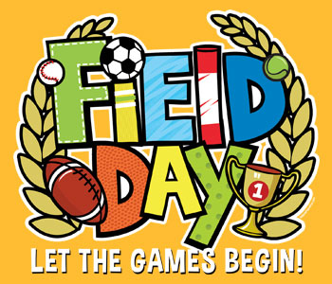
Dear Parents/Guardians,
KONA Ice will be at school on May 25th. Students who haven’t missed a day of school (and haven’t come to school late or left early) will get to purchase a treat from KONA Ice. All word lists and book logs are due on Friday, May 27th.
Field Day is Monday. Students may bring water, a towel, sunglasses, and please make sure they wear sunscreen.
These last few weeks will be busy ones as we approach end of the year testing and also end of the year celebrations. Keep an eye on the side bar for upcoming events.
Sincerely,
Mrs. Jett, Mrs. McHolland, Mrs. Fluharty
April Students of the Month
Caden Frost
Brynlee Eskridge
Cody Ouch

What we are studying
this week in 1st Grade
Math:
- Geometry
- Judith Viorst Author Study
- Text Features
- Writing: Constructed Responses
- Phonics: Review
Science: Engineering

